Control Group: Learning Content
  - v1.0

Key Terminology
These terms are used throughout the control group’s learning content.
Introduction & Context
- Gross Domestic Product (GDP) – The total value of everything a country produces in a year. It measures the size of the economy, not the wellbeing of the people in it.
- Subjective Wellbeing – How people say they feel about their own lives.
- Life Satisfaction (LS) – The most widely used kind of Subjective Wellbeing. It is measured by asking “Overall, how satisfied are you with your life nowadays?”, answered from 0 (not at all satisfied) to 10 (completely satisfied).
Reading Wellbeing Distributions
- Distribution – The whole spread of Life Satisfaction scores across a population, rather than a single average.
- Wellbeing groups – Labels for ranges of scores: Struggling (0–3), Just getting by (4–5), Comfortable (6–8) and Thriving (9–10).
- Mean (average) – All the scores added up and divided by the number of people. It answers “How happy is the typical citizen?”
- Floor (minimum) – The lowest score in the population. It answers “How badly off are the most vulnerable people?”
- Dispersion (inequality) – How spread out the scores are. A wide spread means high inequality.
- Range – A simple measure of dispersion: the gap between the lowest and highest scores.
Policy Frameworks
- Social Welfare Function (SWF) – A rule that combines everyone’s wellbeing scores into a single measure of national success, so outcomes can be ranked.
- Benthamite approach – Aims for the highest total wellbeing by raising the mean. Every point counts the same, whoever receives it.
- National Average Life Satisfaction (NALS) – The measure a Benthamite government aims to raise.
- Rawlsian approach – Judges a society by how it treats its most vulnerable, and aims to raise the floor.
- Minimum Wellbeing Baseline (MWB) – The measure a Rawlsian government aims to raise: the score of the worst-off person.
- Veil of Ignorance – Choosing how society should work without knowing where you will end up in it.
Utility Theory
- Linear – Treating every 1-point gain as equal, wherever it happens on the scale.
- Utility – The value of a 1-point gain in Life Satisfaction, which depends on where the person starts.
- Diminishing marginal utility – Each extra (“marginal”) point of Life Satisfaction is worth a little less than the one before it.
- Utility curve – A graph of how much utility each point on the Life Satisfaction scale is worth. It is steep at the bottom and flat at the top.
- Gamble – A choice between a sure outcome and a risky one that could go up or down. Researchers use people’s choices between gambles to work out utility curves.
- Cautious – Only accepting a gamble when the chance of losing is very small.
- Societal Utility (social utility) – How people value a gain in Life Satisfaction when deciding for other people, behind the veil of ignorance.
- National Fairness Index (NFI) – The measure a government using Societal Utility aims to raise.
- Personal Utility – How a person values changes in their own Life Satisfaction, based on choices about their own life.
- National Personal Satisfaction (NPS) – The measure a government using Personal Utility aims to raise.

Introduction & Context

Measuring Human Progress
  - Why Life Satisfaction is replacing Gross Domestic Product in policy evaluation.
For decades, governments have judged how well a country is doing using economic measures. The most important one is Gross Domestic Product (GDP), which adds up everything a country produces in a year, such as cars sold, houses built and hours worked.
GDP was designed to measure the size of the economy, not the wellbeing of the people who live in it.
GDP tells you how fast the economic engine is running. It does not tell you if the journey is any good.
A country's GDP can keep growing while the gap between rich and poor gets wider, while the environment is damaged and while communities fall apart. None of that shows up in the GDP figure, and GDP says nothing about how the money is shared out.
Side Note: What GDP Ignores
Some things add almost nothing to GDP but still matter a lot to people. Less noise pollution and more community social care are two examples. A wellbeing measure can pick up the value of things like these, because it asks people how their lives are going.
That gap between "the economy is growing" and "people are doing well" is why many governments now look at Subjective Wellbeing. This measures how people say they feel about their own lives, so it puts people first rather than money.
Defining Life Satisfaction
Life Satisfaction is one kind of Subjective Wellbeing, and it is the one most widely used in government statistics. It is the evaluation people make of their own life, when they weigh up what they have achieved against their own standards and hopes.
Side Note: Asking the Question
Life Satisfaction is measured by asking: "Overall, how satisfied are you with your life nowadays?" People answer on a scale from 0 ("not at all satisfied") to 10 ("completely satisfied"). Everything else you will read builds on that 0-10 score.
In the UK, the average score is around 7 out of 10. But that single number hides a lot of variation between regions, age groups and income levels. The next page shows how to read what is hidden inside an average.
Moving Forward
Once we can measure wellbeing, a bigger question follows: how can a government use it to design policies that improve the lives of millions of people, and not just judge the results afterwards?

Reading Wellbeing Distributions
  - How to interpret population wellbeing data: averages, floors, and inequality.
A country's GDP per person is an average. It is the total amount the country produces, divided by the number of people. Like any average, it can look healthy while hiding how things are spread out. Two countries can have the same GDP per person and very different lives inside them.
Life Satisfaction has the same weakness if we only look at its average. Every citizen answers the survey question with a score from 0 to 10, so a government ends up with millions of individual scores, not just one number. Looking at the whole spread of scores shows what a single average cannot.
We sometimes group people by their score:
- Struggling: 0 to 3
- Just getting by: 4 to 5
- Comfortable: 6 to 8
- Thriving: 9 to 10
Three features of that spread matter most for policy: the mean (average), the floor (minimum) and the dispersion (spread).
The Mean (Average)
The mean is found by adding up all the scores and dividing by the number of people. It answers the question: "How happy is the typical citizen?"
A high mean can hide serious problems, because a group with very high scores can pull the average up and cover for a large group with very low scores. So a high mean does not always mean that a country is doing well.
Take two towns that both have a mean of 5.5. In Town A, most people score between 4 and 7, which is a broad and steady middle. In Town B, the population is sharply divided, with large groups scoring either 3 or 8. The average is the same, but the two towns are very different places to live.
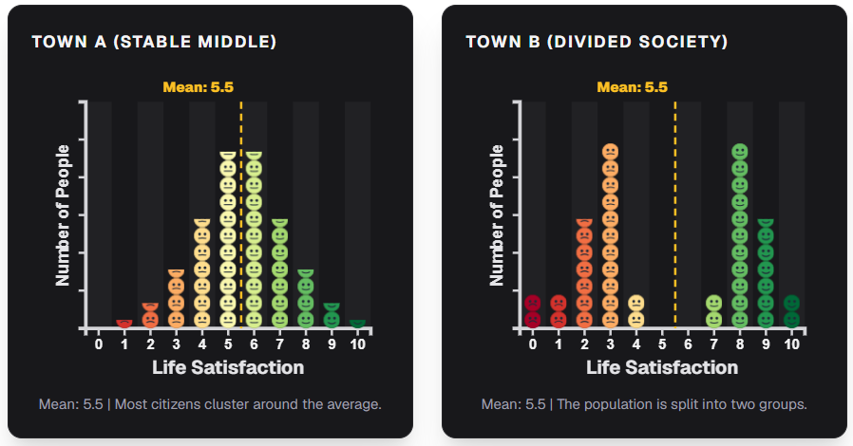
The Floor (Minimum)
The floor is the lowest score in the population, so it shows how the worst-off people are doing. It answers the question: "How badly off are the most vulnerable people?"
Two societies can have the same mean but very different floors. For example, both might average 5.0, but in Society A the most vulnerable citizens score 2, while in Society B the floor is 4.
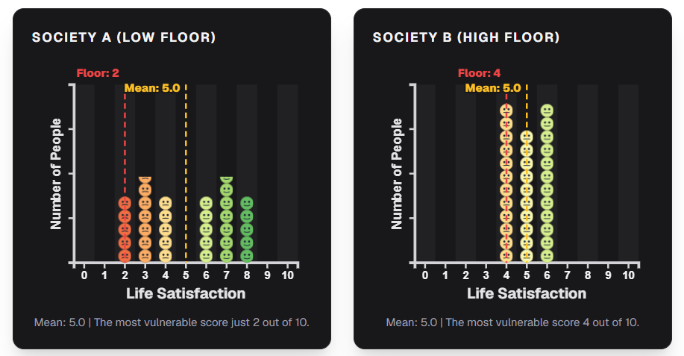Dispersion (Inequality)
Dispersion is how spread out the scores are, and a wide spread means high inequality. A simple way to describe it is the range: the gap between the lowest and highest scores.
Picture two societies that both average 5.0. In the first, almost everyone scores between 4 and 6. The lowest score is 3 and the highest is 7, so the range is 4 points. That is low dispersion. In the second, scores are spread evenly from 0 to 10, so the range is 10 points. That is high dispersion. The mean is identical, but the second society is far more unequal.
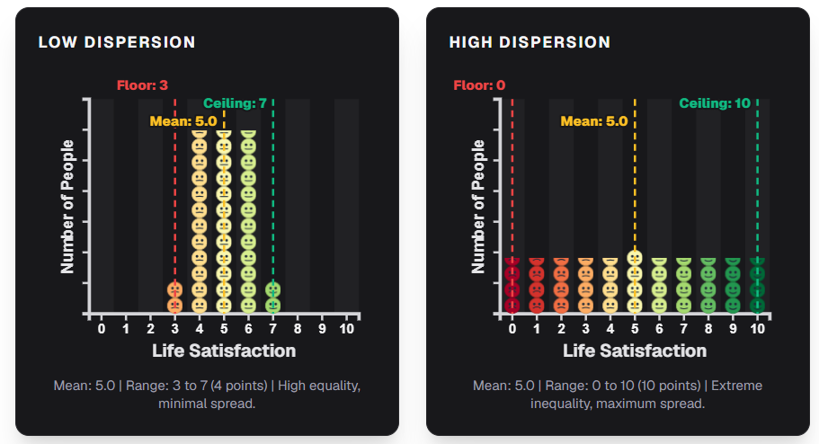What Policies Can Change
Different policies, and different ways of choosing between policies, affect these three measures in different ways. One policy might raise the mean and leave the floor where it was. Another might lift the floor and barely move the mean. A third might narrow the spread. Knowing which measure a policy moves is the first step in judging whether it is working.
Now that you can read what a set of scores is telling you, the next question is how a government turns the mean, the floor or the spread into a target for policy.

Policy Frameworks

Social Welfare Functions
  - How governments aggregate individual happiness into a single national target.
When judging public policy, a government has to decide how to balance the competing needs of its citizens. To do this in a mathematical way, economists use a Social Welfare Function (SWF).
An SWF is a rule that combines everyone's wellbeing scores into a single measure of national success. This lets us rank one outcome as better or worse than another.
An SWF can be built to care about more than the average. Two societies might share the same mean (average) Life Satisfaction. An SWF could still rank one of them lower if its floor (minimum) is much lower.
There is no single agreed-upon SWF. Choosing one is an ethical and political decision, not just a mathematical one. It decides whether a government puts the most weight on growth, on equality, or on protecting people who are struggling. In practice it is not a single either-or choice. There is a spectrum of possible SWFs, from caring only about the total to caring only about the worst-off, with many positions in between.
Two traditional ways of doing this sit at opposite ends of that spectrum:
- Benthamite Aggregation: aim for the highest total wellbeing (maximising the mean).
- Rawlsian Justice: aim for the highest wellbeing for the worst-off person (maximising the minimum).
Before we explore newer ideas, we need to understand how these two foundational approaches work and where each one falls short.

Benthamite Aggregation
  - Maximising total happiness across the population.
The simplest approach to wellbeing policy is called Benthamite Utilitarianism. It is named after the philosopher Jeremy Bentham. Its goal is easy to state: make total happiness as high as possible. Its strength is that it is simple: one number to track, with every person's score counting equally.
Under this approach, a government has done well if the average Life Satisfaction across the population goes up. We can call this the National Average Life Satisfaction (NALS). The idea is often summed up as "a rising tide lifts all boats".
Imagine a country where half the people are comfortable (scoring 6 to 8) and half are just getting by (scoring 4 to 5). A policy raises the score of everyone in the comfortable half by 1 point. The national average goes up, so by Benthamite logic this is a clear win. The average rises whoever gets the gain, so it counts as a win even though the other half is no better off.
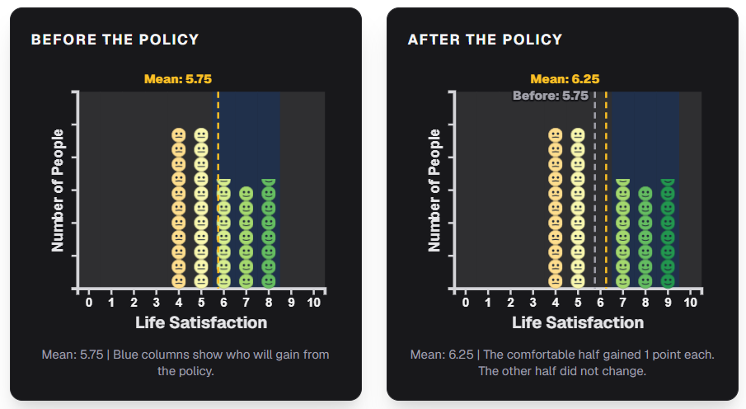
What the Average Leaves Out
Go back to Town A and Town B from the last page. They had the same mean, so a Benthamite government would rate them as equal. It only looks at the average.
The average also cannot tell some policies apart. In Town B, suppose one policy lifts everyone who scores 8 up to 9, and another lifts everyone who scores 3 up to 4. If the two groups are the same size, the mean rises by the same amount either way. The first policy helps people who were already doing well. The second helps people who were struggling. Under Benthamite logic, they are equally good.
A Benthamite government never has to ask how the worst-off people are doing, only whether the average went up. It can even justify large losses for some people, as long as other people gain more. A policy that makes the worst-off worse off can still win, if the better-off gain enough.

The Rawlsian Approach
  - Judging a society by how it treats its most vulnerable.
The Rawlsian approach takes a different view from simple averages. It argues that a society should be judged by how it treats its most vulnerable citizens, not by how well it does on average.
Side Note: The Veil of Ignorance
The philosopher John Rawls asked people to imagine the following: you have to choose how society works, but you do not know where you will end up in it. You could be rich or poor, healthy or ill. Rawls argued you would choose a fair system that protects the worst-off, because that person could be you.
Instead of trying to raise the average, this approach puts all its political effort into raising the floor (minimum), which is the Life Satisfaction score of the worst-off person. We can call this the Minimum Wellbeing Baseline (MWB). Rawlsian policies are designed to protect the worst-off, even if that limits the gains for people at the top.
Why the Floor Isn't Everything
In its strictest form, the Rawlsian approach can become inflexible. Suppose one policy raises the worst-off person's score by a tiny fraction of a point, while another leaves them exactly where they are but transforms life for almost everyone else. If only the floor matters, the first policy must win. Most people find that hard to accept once the gains for everyone else become large enough, which suggests that the floor cannot be the only thing that matters, even to people who care most about the worst-off.
There is a deeper problem too. The Rawlsian approach looks at the raw 0-10 score of the worst-off person and tries to raise it, but it never asks how much a change is really worth to that person. The Benthamite approach has exactly the same blind spot. We'll come back to that.
You will see both frameworks used on real policy over the next two pages. Then we return to the question they both leave out.

Applying Policy Frameworks

Applying Benthamite Policy
  - Real-world examples of policies designed to maximise total wellbeing.
Benthamite thinking shows up whenever a policy is judged by whether the overall average goes up. The gains do not have to be shared evenly. Common examples include:
- Broad tax cuts, which boost spending and economic activity across the income scale
- Corporate deregulation, which gives a big boost to top earners but can weaken protections for the lowest earners
- Universal infrastructure investment (roads, broadband, transport links), which helps productivity and daily life across the country
- Public health campaigns aimed at everyone, like general anti-smoking adverts, rather than at high-risk groups
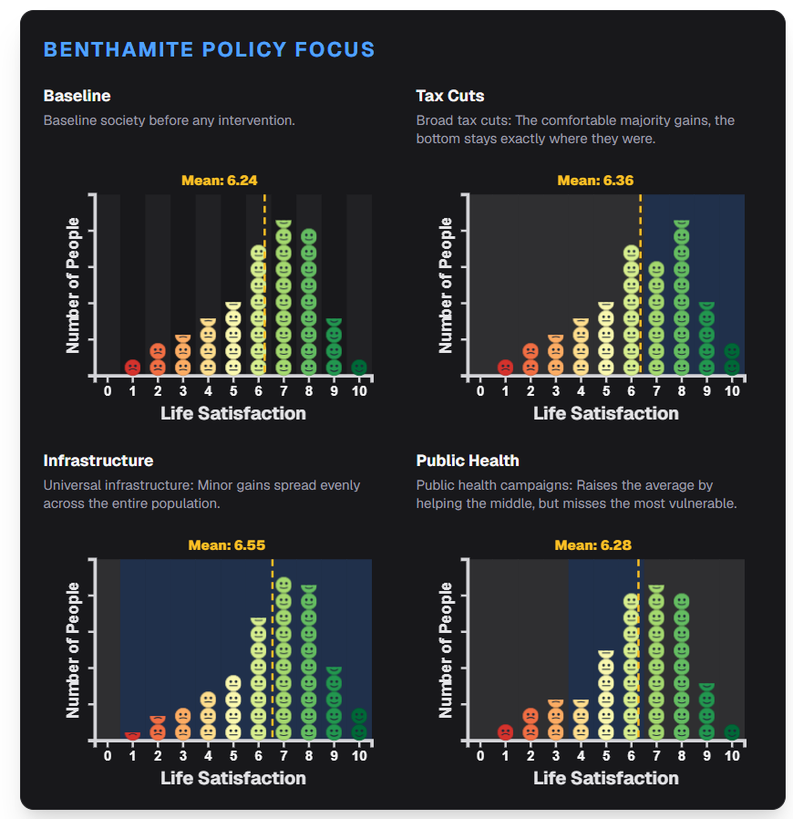
The Common Thread
Each of these policies passes one test: does the national average Life Satisfaction go up? It does not matter whether the gains go to people who were already comfortable or are spread out evenly.

Applying Rawlsian Policy
  - Real-world examples of policies designed to protect the worst-off.
Now let's look at Rawlsian thinking in practice. It shows up when a policy is aimed at raising the minimum, even at some cost to people who are already doing well. Common examples include:
- Means-tested welfare payments, paid only to people below a set level of hardship
- A Universal Credit uplift, which gives more money to the poorest households and is paid for with higher taxes on middle and high earners
- Minimum wage laws, which lift the lowest wages without directly affecting high earners
- Targeted social housing, paid for by progressive taxes and given to the most vulnerable people
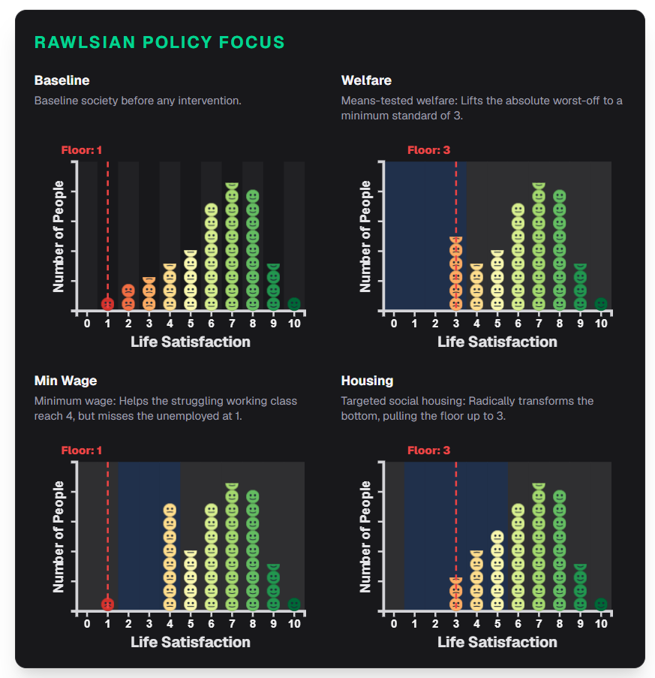
Take the same country as the Benthamite example: a comfortable majority and a struggling minority. A Rawlsian policy aims at the struggling minority. It barely moves the national average, so by Benthamite logic it looks weak. But it does something the Benthamite policy never did. It lifts the worst-off people off the floor.
The Common Thread
Each of these policies is a success if the floor rises. Where the average ends up matters less. So does how much better off comfortable people become. Sometimes the policy comes at their expense.
So far you have seen two clear but opposite answers to "what should a policy achieve?": raise the average, or raise the floor. Both work directly from the raw 0-10 score. The next page asks what a single point on that scale is really worth to different people.

Utility Theory

The Mathematics of Utility
  - Why a 1-point gain in satisfaction is not always equally valued.
The Benthamite and Rawlsian approaches both use the raw 0-10 Life Satisfaction score, and neither asks how much a point is really worth to the person who gets it. A rise from 2 to 3 counts the same as a rise from 8 to 9, simply because both are "1 point". In maths, counting every point as equal is called treating gains as linear.
Research suggests that many people do not value every point equally. Escaping real hardship may matter far more than adding a little extra comfort to an already good life.
This is where utility comes in. Utility is how much a person values being in a given situation. A score tells us where someone is on the scale. Utility tells us how much a move along the scale matters to them. Put simply, utility is the value of a 1-point gain in Life Satisfaction, which depends on where the person starts. Research suggests that for most people, utility follows a curve of diminishing marginal utility. This means each extra point of Life Satisfaction ("marginal" just means "extra") is worth a little less than the one before it.
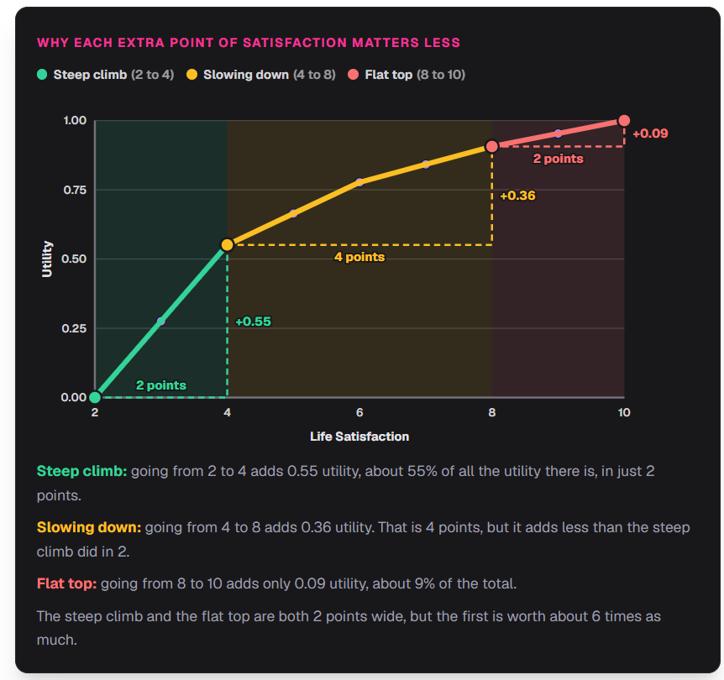
The curve starts at a score of 2. That is the lowest situation the research asked people about, and very few people in the UK score lower. So we treat 2 as the starting point, with a utility of 0.
From there, utility climbs steeply at first (the steep climb), slows down, and then flattens out (the flat top). Going from 2 to 4 is worth about 0.55 of all the utility there is. Going from 8 to 10 is a step of exactly the same size, but it is worth only about 0.09. The diagram marks each part of the curve and shows how much utility each step adds.
So where a gain happens matters as much as how big it is.
A Shift in Perspective
Money makes this easier to see. Say someone on a low income receives an extra £100. It might decide whether they can heat their home all winter, which is a huge change. Now give the same £100 to someone who is already comfortable. They barely notice it, because it disappears into savings or spending they would have done anyway. The amount is identical, but what it does for their wellbeing is not.
The figure below shows how the same +1 Life Satisfaction boost is worth very different amounts depending on where someone starts. It follows four people, starting at 2, 4, 6 and 8, and the highlighted steps on the curve show what the boost adds for each of them.
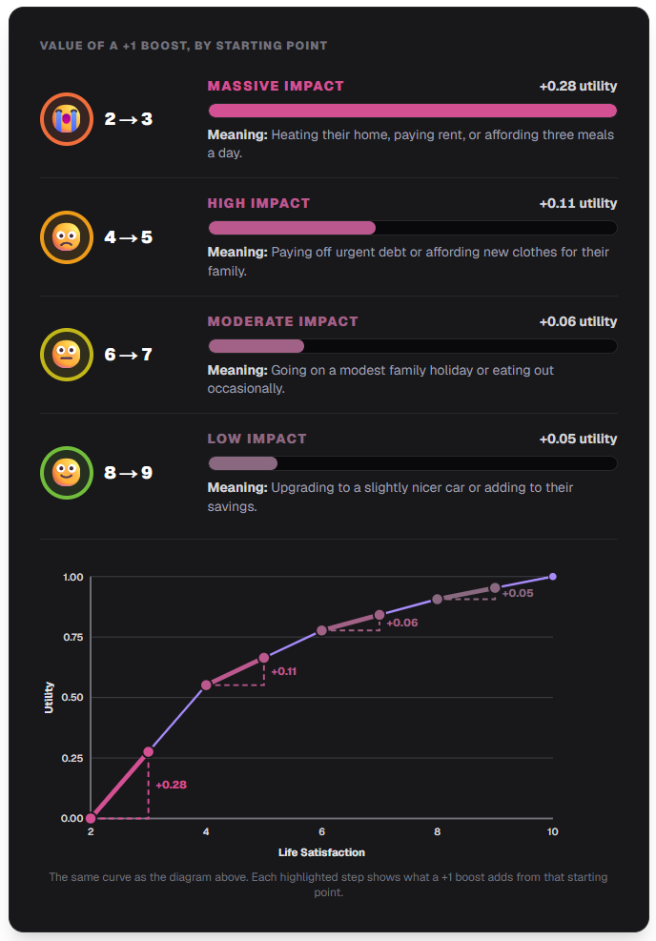Because a point is worth more at the bottom, a government that counts utility will naturally care more about the worst-off, without ever having to say so. Rawls reached a similar place through a fairness argument, while utility theory gets there by asking what a gain is actually worth.
This puts utility between the two approaches you have already seen. The Benthamite approach counts every point the same. The Rawlsian approach counts only the worst-off. Utility counts every point, but counts points at the bottom for more. The steeper the curve is at the bottom, the closer it sits to the Rawlsian end. The flatter (straighter) it is, the closer it sits to the Benthamite end.
Deciding for Others or for Yourself
Diminishing marginal utility is the first big idea, and it is enough on its own to explain why a point is not always worth the same. But there is a second idea, which is about whose outcome is being judged. People think differently about outcomes for other people than about risks to their own life. The next page explains how researchers measure a utility curve, and how the same method gives one curve for decisions made for others and another for decisions about yourself.

Where Utility Curves Come From
  - How researchers turn people's choices between gambles into a utility curve.
The last page showed a utility curve. But nobody can look inside someone's head and read off how much a point of Life Satisfaction is worth to them. So where does the curve come from?
Researchers ask people to make a series of choices and turn those choices into numbers. Each choice is between a sure thing and a gamble.
Choosing Between Gambles
First, people read short descriptions of imagined lives, from very good to very hard, and give each one a Life Satisfaction score. Most people score these lives at about 10, 8, 6, 4 and 2.
Then they make choices like this one:
Example: A Choice for a Group of Citizens
A large group of people all have a Life Satisfaction of 6. The government can fund one of two policies for them.
Policy A: everyone stays at 6. This outcome is certain.
Policy B: some people rise to 8, but others fall to 4. No one can tell beforehand who will benefit.
You belong to this group too, but you don't know whether you would be one of those who rise or one of those who fall.
The share of people who fall starts high, at 1 in 2. It then gets smaller step by step (1 in 5, 1 in 10, 1 in 100, 1 in 1,000, and so on) until the person is willing to choose Policy B. That switching point shows how much they fear the step down compared with how much they want the step up. If someone will only take the gamble when very few people would fall, the step down must matter far more to them than the step up.
Repeating this at different starting points (4, 6 and 8) traces out the whole curve, one step at a time.
Two Versions of the Same Gamble
The same kind of gamble can be asked in two ways:
 | Choosing for others | Choosing for yourself
The question | Which policy would you fund for a group of citizens? | Which treatment would you choose for your own life?
Whose Life Satisfaction is at risk | Other people's (and maybe yours, but you don't know which group you would be in) | Your own
The curve it gives | Societal Utility | Personal Utility
The version about your own life looks like this:
Example: A Choice About Your Own Life
Imagine your Life Satisfaction is 6. You have had a health condition all your life, and your doctor says you must choose between two treatments.
Treatment A: you stay at 6. This outcome is certain.
Treatment B: if it works, you rise to 8. If it fails, you fall to 4.
Here it is the chance that the treatment fails that starts at 1 in 2 and gets smaller.
The curves on the next two pages are the averages of the answers given by about 300 UK adults. So a utility value is not a guess: it comes from the risks people would accept in gambles like these. The next page starts with the choices people make for others.

Societal Utility
  - How people value wellbeing when deciding on behalf of others.
Societal Utility (also called social utility) measures how people value a gain in Life Satisfaction when they are deciding for other people. It comes from the gambles on the last page that were made for a group of citizens.
Behind the Veil of Ignorance
In those gambles, you belong to the group, but you do not know whether you would be one of the people who rise or one of the people who fall. This is the veil of ignorance from The Rawlsian Approach: choosing how society should work without knowing where you will end up in it.
When people choose like this, they tend to be cautious. They only back a policy that drops some people down if very few people would fall. In their eyes, a drop for someone else counts for more than an equal rise.
That caution shows up in the curve. It climbs very steeply at the bottom and is almost flat at the top, so lifting the worst-off counts for much more than adding to people who are already doing well.
Life Satisfaction | Societal Utility | +1 Point Is Worth
2 | 0.00 | —
3 | 0.36 | +0.36
4 | 0.72 | +0.36
5 | 0.80 | +0.08
6 | 0.87 | +0.08
7 | 0.91 | +0.04
8 | 0.95 | +0.04
9 | 0.97 | +0.03
10 | 1.00 | +0.03
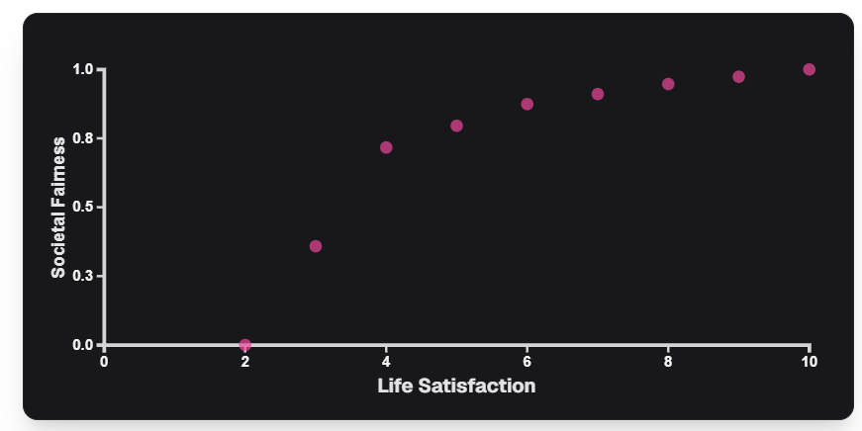
Look at the "+1 Point Is Worth" column: it is greenest at the bottom and reddest at the top.
A government that follows this idea judges each policy by how citizens would value the result if they were responsible for everyone else. The measure it aims to raise is the National Fairness Index (NFI).
The Case for Societal Utility
Governments make decisions on behalf of millions of people: how to share a budget, whose wellbeing to prioritise, and which group has to bear a cost. Societal Utility reflects what people endorse when they are responsible for others. If people are this careful when a choice is about other people's lives, perhaps a government, which is always choosing for others, should be careful too.
But people do not only make choices for others. They also make choices about their own lives, and there they choose differently. The next page looks at that.

Personal Utility
  - How people value gains and losses when deciding about their own lives.
Personal Utility measures how a person values changes in their own Life Satisfaction. It comes from the same kind of gamble as Societal Utility, but this time the choice is about your own life: a sure outcome, or a treatment that might make things better or worse.
People Take More Risks for Themselves
Most people choose more riskily for themselves than they would for others. Faced with the same odds, they are more willing to gamble with their own life than with the lives of a group of citizens. Put the other way round, people are more cautious with other people's lives than with their own.
Because people are less cautious about their own lives, the Personal Utility curve is less steep at the bottom. Lifting the worst-off still counts for more than adding to people who are already doing well, but by less than under Societal Utility.
Life Satisfaction | Personal Utility | +1 Point Is Worth
2 | 0.00 | —
3 | 0.28 | +0.28
4 | 0.55 | +0.28
5 | 0.66 | +0.11
6 | 0.78 | +0.11
7 | 0.84 | +0.06
8 | 0.91 | +0.06
9 | 0.95 | +0.05
10 | 1.00 | +0.05
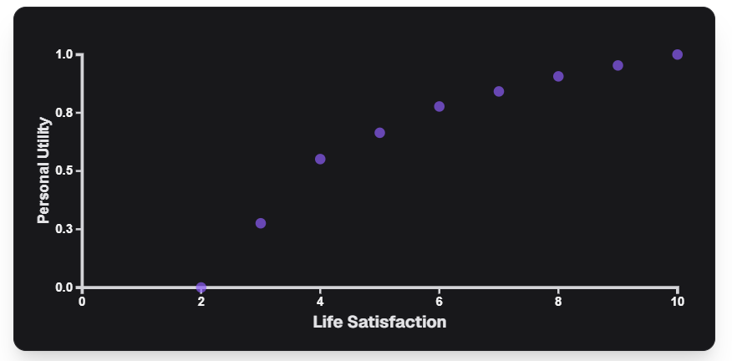
A government that follows this idea judges each policy by how each citizen values the change in their own life. The measure it aims to raise is the National Personal Satisfaction (NPS).
Comparing the Two Curves
The chart below puts both curves on the same axes. They mostly agree about gains near the top. They split apart at the bottom, where Societal Utility gives the worst-off much more weight.
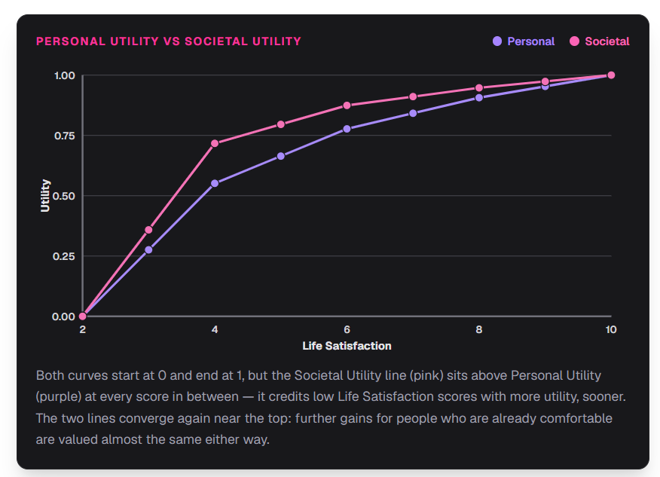
One way to see the gap is to score each curve out of 10 points and ask how many points lifting one person from 2 to 4 is worth. Under Societal Utility it is worth about 7.2 points. Under Personal Utility it is worth about 5.5. If every point counted the same, as in the Benthamite approach, it would be worth 2.5 (2 of the 8 steps from 2 to 10).
Side Note: What Real People Think
A UK study asked 300 adults to make choices about risks to their own lives and about outcomes for society. About 4 in 5 (79%) were cautious in choices about their own lives. Nearly 9 in 10 (87%) were cautious in choices about society. Almost three quarters (73%) were more cautious when choosing for society than when choosing for themselves. These views were not linked to how people voted. (These figures leave out choices involving death.)
The Case for Personal Utility
Personal Utility respects the choices people make for their own lives. Nobody knows your life better than you do. If you would accept a risk for yourself, why should a government be more cautious on your behalf than you would be?
The Dilemma
So a government that wants to use utility has to choose. Societal Utility gives the worst-off more weight than Personal Utility does, so the two can recommend different policies. The next page shows this happening.

Applying Utility Theory

Applying Utility to Policy
  - Evaluating the same policy through societal utility and personal utility logic.
Let's test both curves on the same policy.
A Worked Example
Take a policy that affects three groups differently. One small group is a little below average and takes a modest hit. Two much larger groups are already doing fine and get a modest boost.
Group | Share | LS Change | Personal Utility | Societal Utility
Lower group | 10% | 4 → 3 | -0.276 | -0.358
Middle group | 45% | 6 → 7 | +0.065 | +0.036
Upper group | 45% | 8 → 9 | +0.047 | +0.026
Population-weighted total |  |  | +0.023 | -0.008
Under Personal Utility, this policy comes out ahead. The gains of the two large groups add up to more than the small group's loss. Under Societal Utility, the same policy becomes a net loss. The group at the bottom counts for more because they are worse off. That extra weight is enough to outweigh the gains that looked fine a moment ago.
Why They Diverge
Both curves agree that a point at the bottom is worth more than a point at the top. They disagree about how much more. Societal Utility comes from choices people make for others, where they are more cautious, so it puts more weight on the worst-off. Personal Utility comes from choices people make about their own lives, where they take more risks, so it puts less weight on the worst-off.
The two views differ most when a policy gives a small loss to people who are worse off and gains to people who are already comfortable. For example, a tax change might slightly reduce support for low-income households and cut taxes for everyone else. It can raise total Personal Utility and still count as a loss under Societal Utility.
Weighing the Same Gain Four Ways
This table shows how much weight each approach gives to the same +1 Life Satisfaction gain, depending on where the person starts. The two utility columns use the curves from the last two pages.
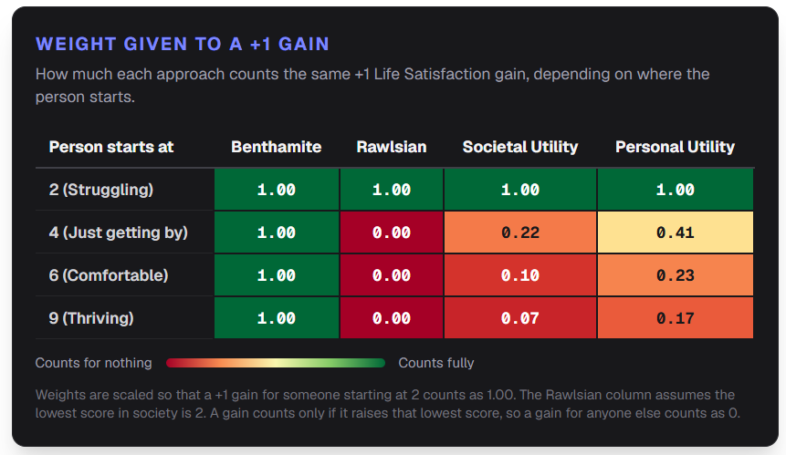
What You Prefer
So a government that uses utility faces a choice. Personal Utility respects the choices people make for their own lives. Societal Utility reflects what people endorse when they are responsible for others. By now you have seen how Benthamite, Rawlsian and utility-based approaches can judge the same policy differently. None of them is simply "correct". Which one you find most convincing is a question of values. After you finish reading, you will be asked which approach you would choose.
This is the last page of the wiki.

